# Practical No. 5. HANDLING MULTIPLE WINDOWS & FRAMES USING SELENIUM

**Date:**

## Aim:

To learn how to handle multiple windows, frames and modals using selenium.

## Theory:

**How to handle Selenium multiple window using Webdriver**

In automation, when we have multiple windows in any web application, the activity may need to switch control among several windows from one to other in order to complete the operation.

After completion of the operation, it has to return to the main window i.e. parent window in Selenium.

## WindowHandle:

*It is a unique identifier that holds the address of all the windows.* Think of it as a pointer to a window, which returns the string value. It is assumed that each browser will have a unique window handle. This window handle function helps to retrieve the handles of all windows.

In Selenium web driver there are methods through which we can handle multiple windows.

## Driver.getWindowHandles();

To handle all opened windows by web driver, we can use “Driver.getWindowHandles()”. This method helps to get the handles of all the windows opened and then we can switch window from one window to another in a web application. Its return type is Iterator<String>.

## Driver.getWindowHandle();

When the site opens, we need to handle the main window by driver.getWindowHandle(). This method helps to get the window handle of the current window. Its return type is String.

## set:

This method helps to set the window handles in the form of a string. set<string> set= driver.get.windowhandles()

## driver.switchTo()

This method helps to switch between the windows

## action:

This method helps to perform certain actions on the windows

## How to handle frames in Selenium Webdriver

Frames in HTML can be used to divide a web-page vertically or horizontally. iFrames is mainly used for displaying external content on a target web page, for example, an advertisement for any online programming course on a web page. An iframe is also known as the inline frame. It is a tag used in HTML5 to embed an HTML document within a parent HTML document. An iframe tag is defined using <iframe></iframe> tags.

It is possible to identify the iframes on a web page in two ways:

* Right-click on the specific element and check all the options. If you find an option like This Frame, view Frame source or Reload Frame, it means the page includes frames.
* Similar to the first step, right-click on the page and click on View Page Source. On the page source, search for “iframe-tags”. If you find any iframe tags, it means the page includes iframes.

To interact with any web element present within any frame, one needs to switch to that particular frame. This allows the user to identify elements present on that page and write tests accordingly.

QAs can switch between frames using the **Switch.frame()** function. The switch function can be implemented using three different locators: By.index, By.id, By WebElement. Refer to the commands below:

## By Index

driver.switchTo().frame(1);

Switches to the frame with index number 1

## By Id or Name

driver.switchTo().frame(“resultframe”);

Switches the frame where the value of id attribute is resultframe

## By Web Element

WebElement iframeElement = driver.findElement(By.id("resultframe")); driver.switchTo().frame(iframeElement);

The WebElement command above identifies the web element and then passes it through

the iframe element object.

## How to handle modals in Selenium WebDriver?

A Modal Dialog Box (also referred to as Bootstrap Modal Window) is built in Bootstrap Framework, due to which it gets displayed on top of your current page. Due to this, modal boxes need to be interacted with first before moving to the current webpage. Switching is not necessary for modals.

## Implementation

1. **Open “flight_reservation.html” and write a script to handle frames and print heading of page in each frame.**

**package** first_practical;

**import** org.openqa.selenium.By;

**import** org.openqa.selenium.WebDriver;

**import** org.openqa.selenium.WebElement;

**import** org.openqa.selenium.firefox.FirefoxDriver;

**public** **class** Exercise8 {

**public** **static** **void** main(String[] args) {

System.*setProperty*("webdriver.gecko.driver", "E:\\Selenium\\geckodriver.exe");

WebDriver driver=**new** FirefoxDriver();

driver.get("file:///G:/imp/Flight_Reservation/flight_reservation.html");

//Switching to Frame1 using index

driver.switchTo().frame(0);

WebElement frame1_heading1=driver.findElement(By.*id*("heading1"));

System.***out***.println("Frame1 Heading: "+frame1_heading1.getText());

driver.switchTo().defaultContent();

System.***out***.println("Title of main window: "+driver.getTitle());

System.***out***.println("Switched to main window");

//Switching to frame 2

driver.switchTo().frame("IF2");

System.***out***.println("This is ifrmae 2");

WebElement frame2_heading1=driver.findElement(By.*id*("heading2"));

System.***out***.println("Frame2 Heading: "+frame2_heading1.getText());

//Switching to sub frmae

driver.switchTo().frame(0);

System.***out***.println("Switched to sub frame inside frame 2 ");

WebElement frame3_heading1=driver.findElement(By.*id*("heading3"));

System.***out***.println("Child Frame Heading: "+frame3_heading1.getText());

driver.switchTo().defaultContent();

System.***out***.println("Title of main window: "+driver.getTitle());

}

}

**Output:**

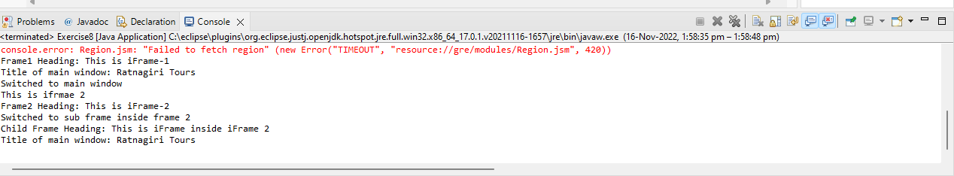

1. **Open *https://demoqa.com/browser-windows* and write a script to handle multiple windows that opens after clicking button “New Window” and print the heading on that new window.**

**package** first_practical;

**import** java.util.Iterator;

**import** java.util.Set;

**import** org.openqa.selenium.By;

**import** org.openqa.selenium.WebDriver;

**import** org.openqa.selenium.WebElement;

**import** org.openqa.selenium.firefox.FirefoxDriver;

**public** **class** Exercise9 {

**public** **static** **void** main(String[] args) {

System.*setProperty*("webdriver.gecko.driver", "E:\\Selenium\\geckodriver.exe");

WebDriver driver=**new** FirefoxDriver();

driver.get("https://demoqa.com/browser-windows");

WebElement newWindowBtn=driver.findElement(By.*id*("windowButton"));

newWindowBtn.click();

//Get handles of the windows

String mainWindowHandle = driver.getWindowHandle();

Set<String> allWindowHandles = driver.getWindowHandles();

Iterator<String> i1 = allWindowHandles.iterator();

**while** (i1.hasNext()) {

String ChildWindow = i1.next();

**if** (!mainWindowHandle.equalsIgnoreCase(ChildWindow)) {

driver.switchTo().window(ChildWindow);

WebElement text = driver.findElement(By.*id*("sampleHeading"));

System.***out***.println("Heading of child window is " + text.getText());

driver.close();

System.***out***.println("Child window closed");

}

}

}

}

**Output:**

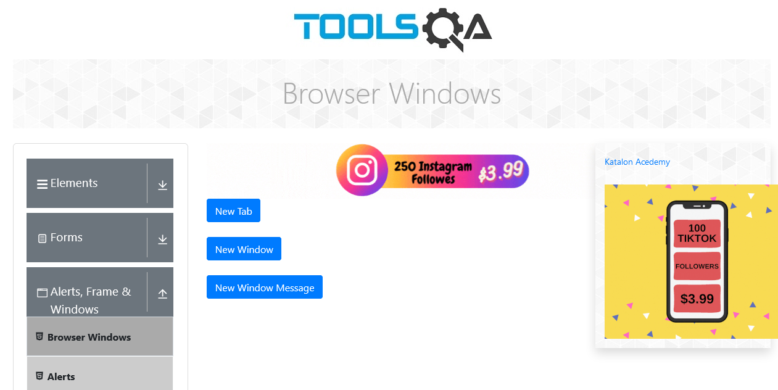

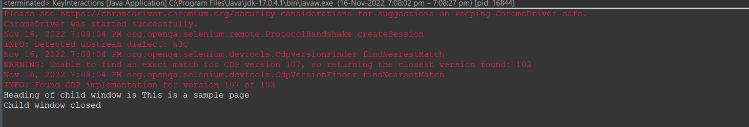

1. **Open “flight_reservation.html” and write a script to handle popup window that opens after clicking on “Hotels” Hyperlink and print title of the popup window and heading on that page.**

**package** first_practical;

**import** java.util.Set;

**import** org.openqa.selenium.By;

**import** org.openqa.selenium.WebDriver;

**import** org.openqa.selenium.WebElement;

**import** org.openqa.selenium.firefox.FirefoxDriver;

**public** **class** Exercise10 {

**public** **static** **void** main(String[] args) **throws** InterruptedException {

System.*setProperty*("webdriver.gecko.driver", "E:\\Selenium\\geckodriver.exe");

WebDriver driver=**new** FirefoxDriver();

driver.get("file:///G:/imp/Flight_Reservation/flight_reservation.html");

String mainWindow=driver.getWindowHandle();//retrieve the unique id of flight reservation window

System.***out***.println("Main Window Handle :"+mainWindow);

System.***out***.println("Title of main window is: "+driver.getTitle());

WebElement hotel_link=driver.findElement(By.*linkText*("Hotels"));

hotel_link.click();

Set<String> handles=driver.getWindowHandles();

**for**(String windowHandle:handles)

{

**if**(!windowHandle.equals(mainWindow))

{

driver.switchTo().window(windowHandle);

System.***out***.println("Title of child window is "+driver.getTitle());

WebElement heading1=driver.findElement(By.*id*("sampleHeading"));

System.***out***.println("Heading inside child window is "+heading1.getText());

Thread.*sleep*(4000);

driver.close();

}

}

driver.switchTo().window(mainWindow);

System.***out***.println("Title of main window: "+driver.getTitle());

}

}

**Output:**

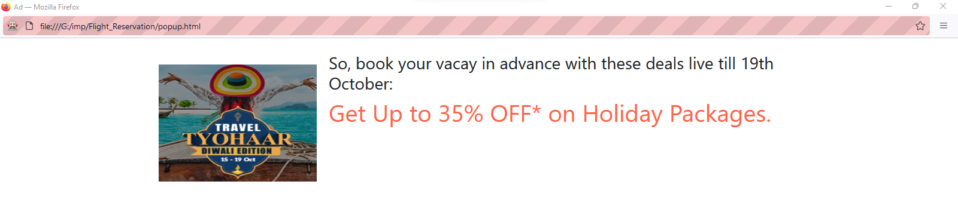

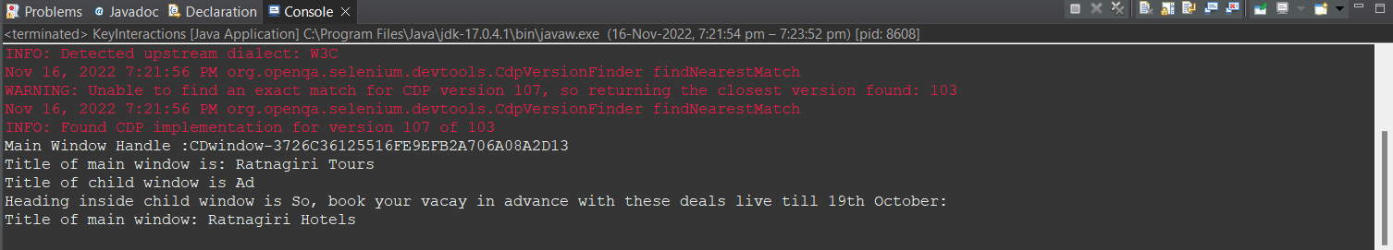

1. **Open “hotel_search.html” page and handle modals that appear after clicking on buttons on that webpage.**

package first_practical;

import java.util.Iterator;

import java.util.Set;

import org.openqa.selenium.By;

import org.openqa.selenium.WebDriver;

import org.openqa.selenium.WebElement;

import org.openqa.selenium.chrome.ChromeDriver;

public class KeyInteractions {

public static void main(String[] args) throws InterruptedException {

// **TODO** Auto-generated method stub

System.*setProperty*("webdriver.chrome.driver", "C:\\Users\\parun\\Desktop\\FAMT\\Cyber Security\\driver\\chromedriver.exe");

WebDriver driver=new ChromeDriver();

driver.get("file:///H:/imp/Flight_Reservation/hotel_search.html");

WebElement hotels=driver.findElement(By.*cssSelector*("button[data-target='#myModal']"));

hotels.click();

WebElement modal_title1=driver.findElement(By.*xpath*("//h4[@class='modal-title']"));

System.***out***.println("Title of modal is : "+modal_title1.getText());

Thread.*sleep*(3000);

WebElement ok_button=driver.findElement(By.*xpath*("//button[@data-dismiss='modal']"));

ok_button.click();

Thread.*sleep*(2000);

WebElement book_room_btn=driver.findElement(By.*xpath*("//button[@id='myBtn1']"));

book_room_btn.click();

WebElement hotelname=driver.findElement(By.*xpath*("//input[@id='htlname']"));

hotelname.sendKeys("Taj Hotel");

WebElement person=driver.findElement(By.*xpath*("//input[@id='prs']"));

person.sendKeys("1");

WebElement days=driver.findElement(By.*xpath*("//input[@id='days']"));

days.sendKeys("6");

Thread.*sleep*(3000);

WebElement cancelbtn=driver.findElement(By.*xpath*("//button[@type='submit'] //following::button"));

cancelbtn.click();

}

}

**Output:**

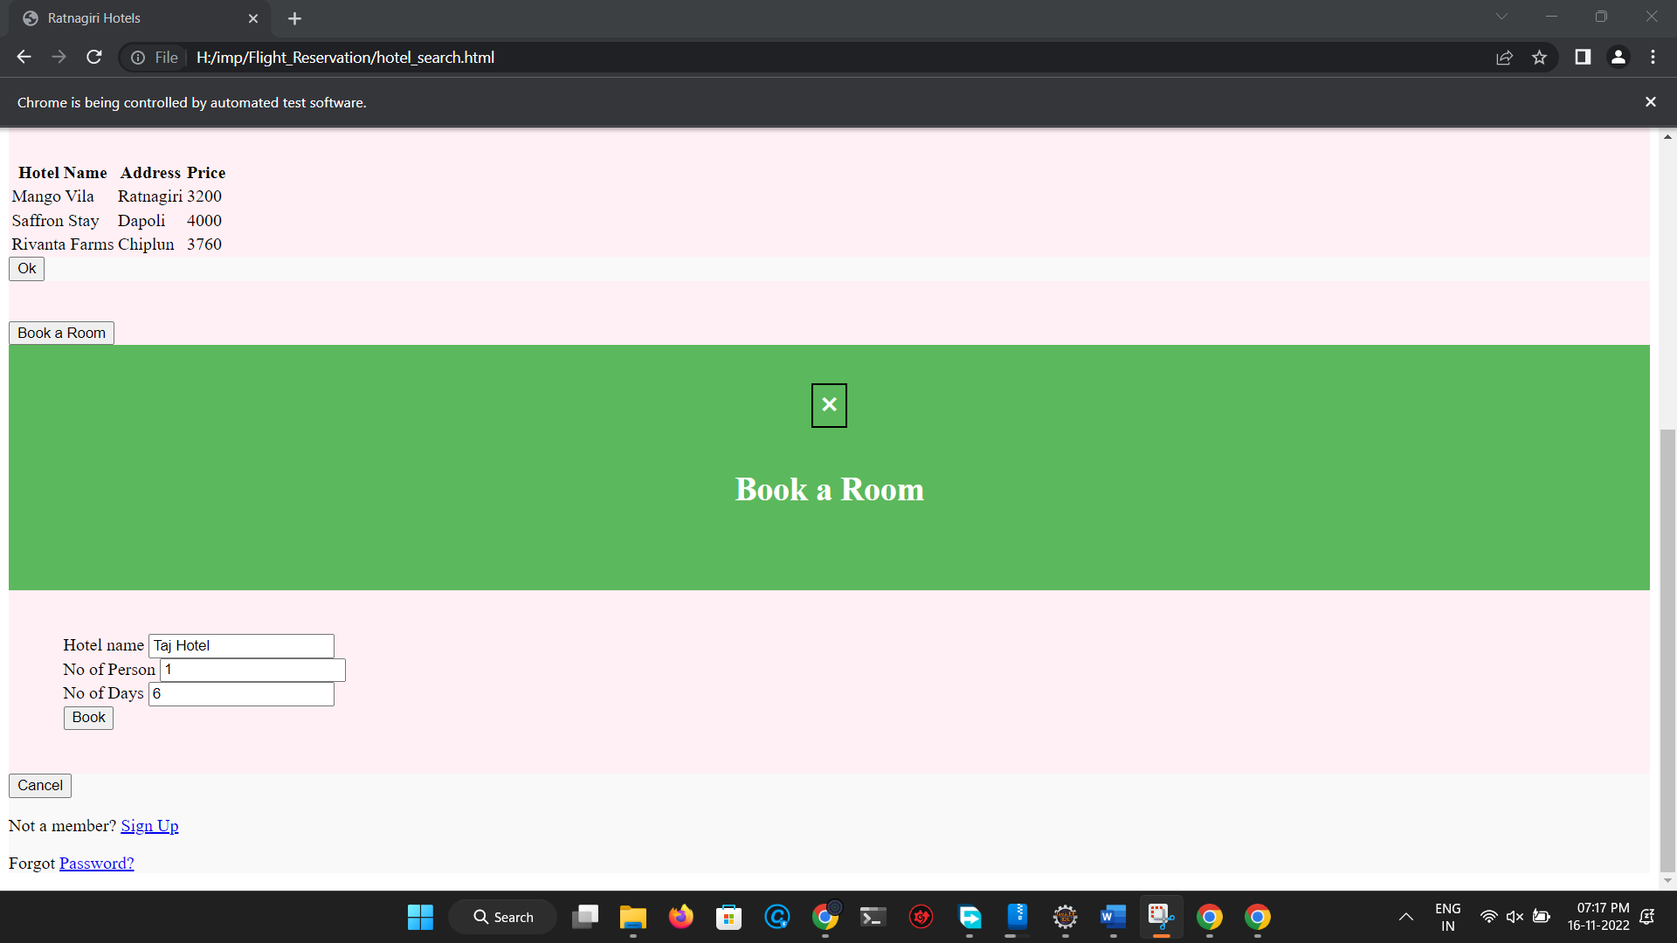

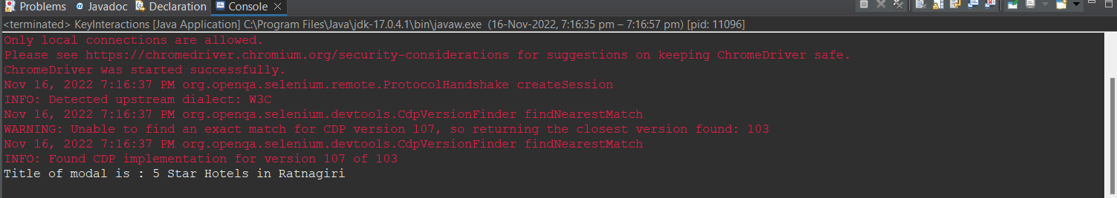

**Conclusion:** Learnt to handle multiple windows, frames and modals in Selenium.

## After performing this Practical/lab, students are expected to answer following questions

* 1. What is iframe?
  2. What is Window handle?
  3. What is switchTo() method?